**Lab Exercise Date 28-02-2019**

1. Write a C-program to construct an RGB image of size 200×200. At the centre of the image (100, 100), there will be circle of radius 25 surrounding which there will be an ellipse of major axis 50 and minor axis 35. Now fill the circle with color1 (R=200, G=50, B=10) and ellipse with color2 (R = 10, G=200, B=50 ) and rest the image with color3(R=50, G=10, B= 200).
2. Convert the above constructed image to HSI and keeping H unchanged, increase the saturation(S) value by 10% and add 50 to each intensity(I) value. Then convert back the HSI-image to RGB and observe the changes.

**Instructions**

1. Take 3 separate matrices for R, G and B components of size 200×200 each.
2. Find the co-ordinates of the circle to be drawn using Bresenham’s circle drawing algorithm and assign respective values to the R, G and B components on these co-ordinates.
3. Fill the inside of the circle by finding the co-ordinates using Flood fill algorithm and assign the colors accordingly.
4. Similar steps can be carried out for drawing the ellipse and filling it. Assign the respective colors to the outer part of the image.
5. Now, write the data of the R, G and B matrices into an image file of .ppm format. The header for .ppm image format is

**P3# CREATOR: GIMP PNM Filter Version 1.1**

**Col_size Row_size**

**Max_pixel_value**

Where **Row_size** and **Col_size** denote the row and column size of the image and **Max_pixel_value** is maximum pixel value present in the image.This header is compulsory for all .ppm format image and the actual data need to be appended to this.

(To visualize the .ppm format image, you have to use **gimp**)

1. Conversion from RGB to HSI has the following formula

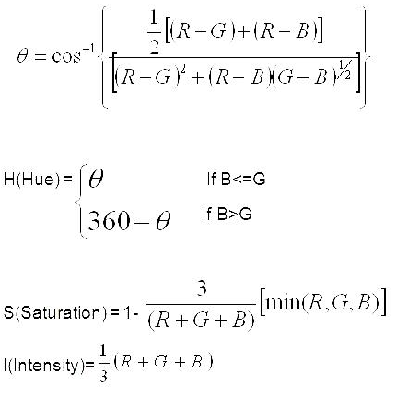

1. Conversion for HSI to RGB

